**Smart Vitals Mobile Application Guidelines**

Smart Vitals system is equipped with mobile application that allows users to get benefits of many features. The step-by-step guidelines on how to get around the mobile application of smart vitals are given below:

**Sign up:**

User can Sign up with a valid email address, fulfilling the password criteria, their emergency contact number and name.

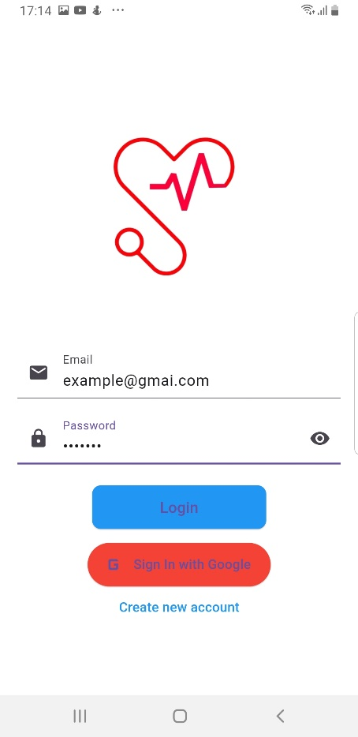 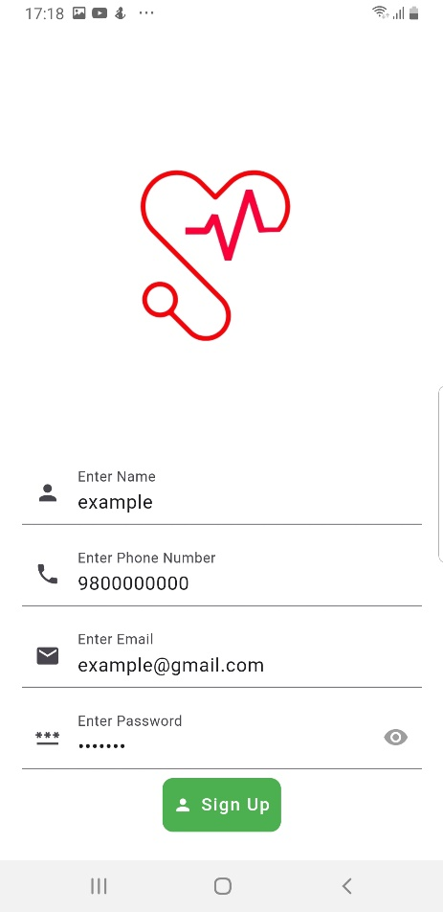

User can also sign up via Google account.

 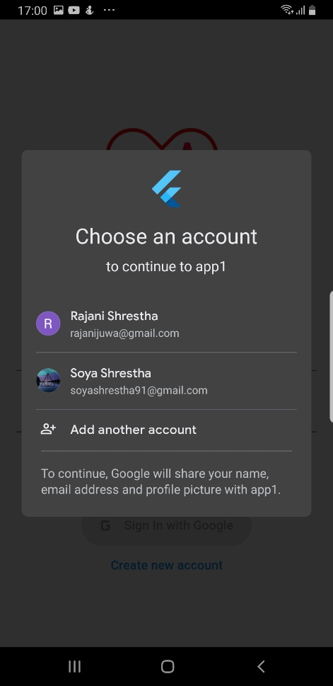

**Login:**

Once users’ account is set up, they can login entering their valid email and password and then clicking on the Login button.



**Dashboard:**

Once the user has logged in with a valid email, they are redirected to dashboard. On the top of the dashboard, they can see air quality, room temperature and location coordinates.

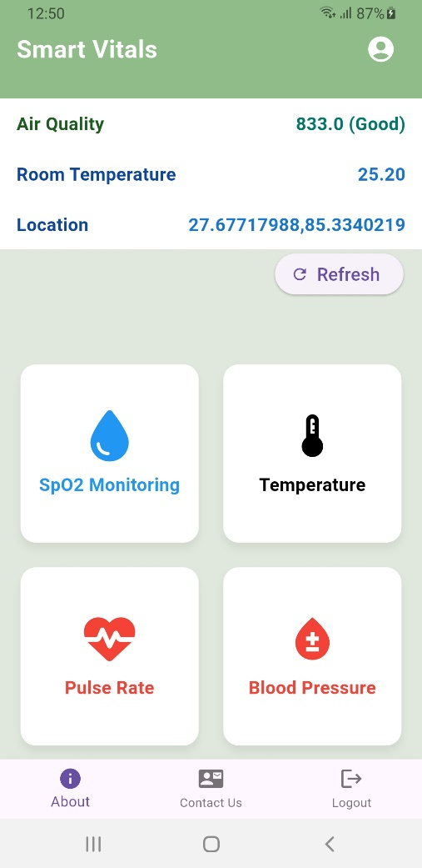

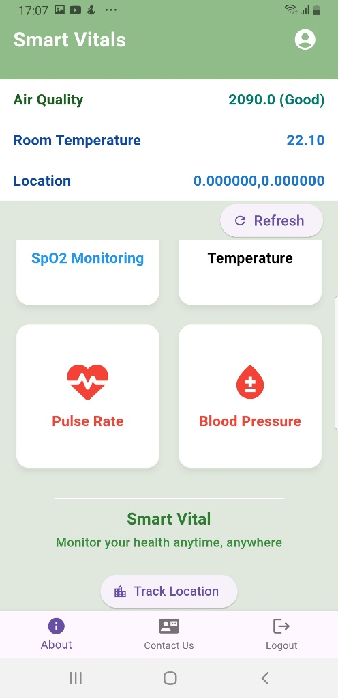

On the main section of the dashboard users can also view, Temperature, SpO2, Heart rate and Blood Pressure cards. Clicking on any one of them redirects them to that vitals’ specific page, where users can view their readings. History of vitals with date and time can be seen.

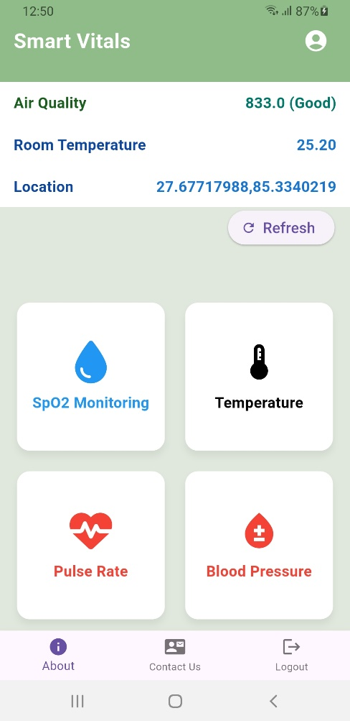

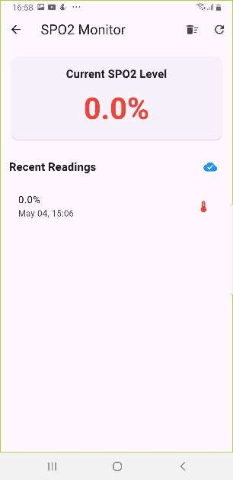 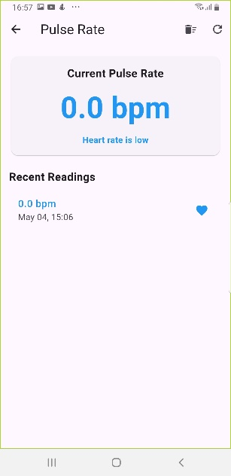 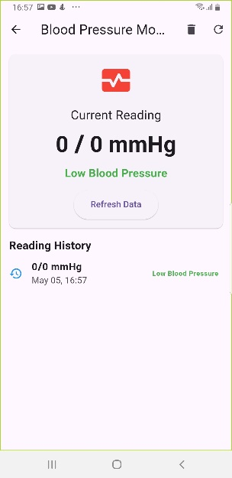 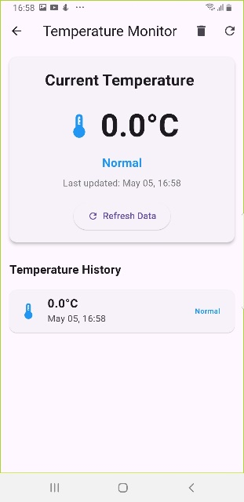

Additionally, users can also save and delete the history per their desire.

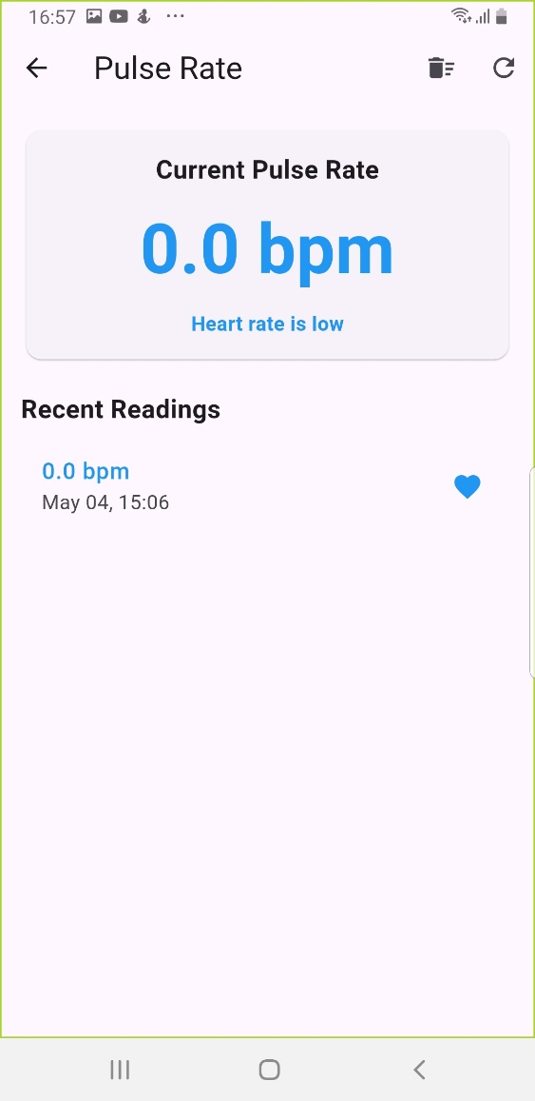

**Location:**

When the user scrolls down, they can view track location button which redirects users to a new page where they can track the current location of the system, which comes in handy in case of emergency.

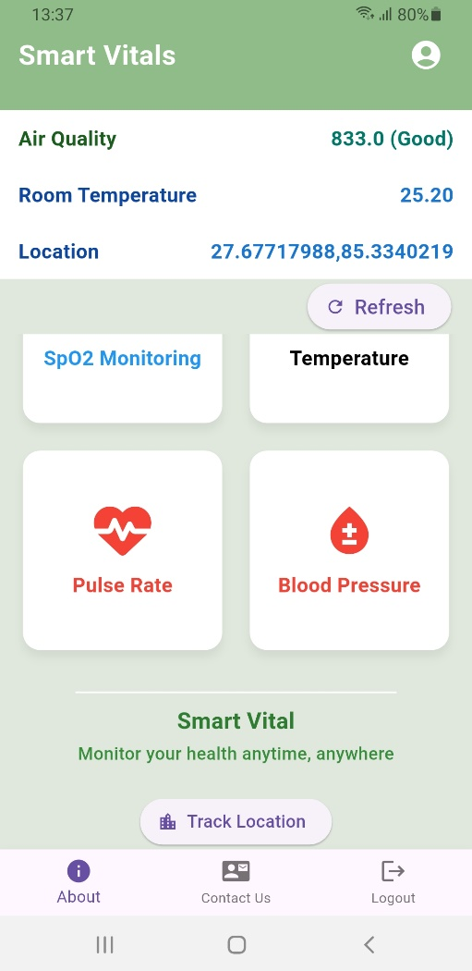 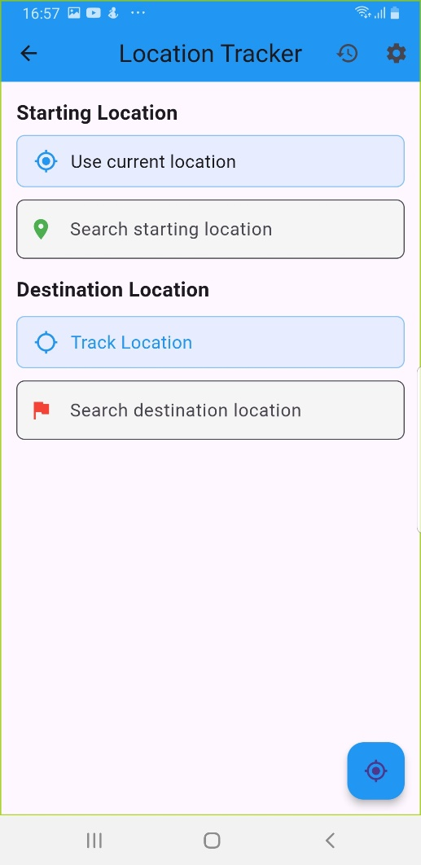

**User Profile:**

The user can view their information on profile icon which is visible on the top right corner of the dashboard.

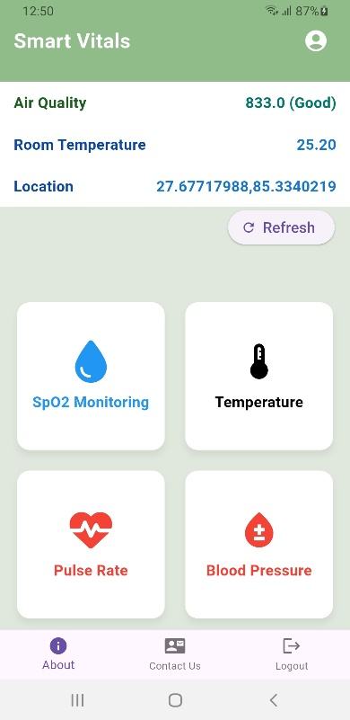 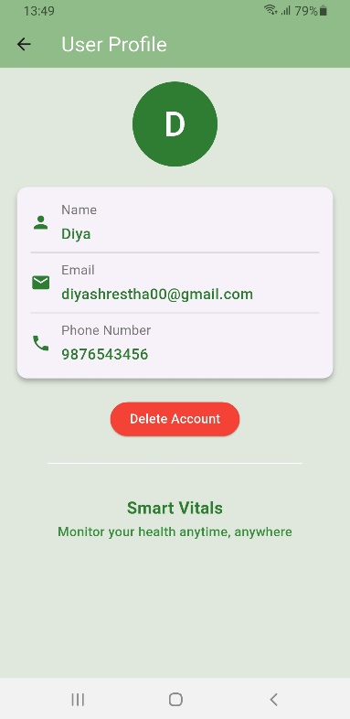

User can click on the delete button to permanently delete their account.

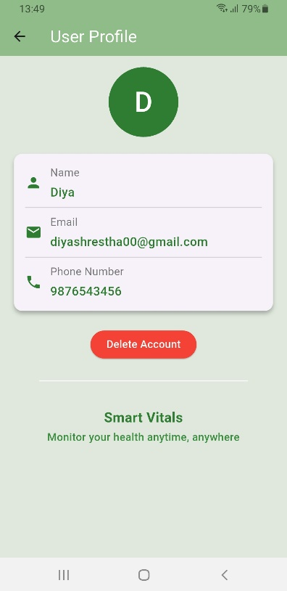

**About Us:**

On the bottom navigation bar, the user can see three icons, the first one is about us icon containing information about smart vitals.

 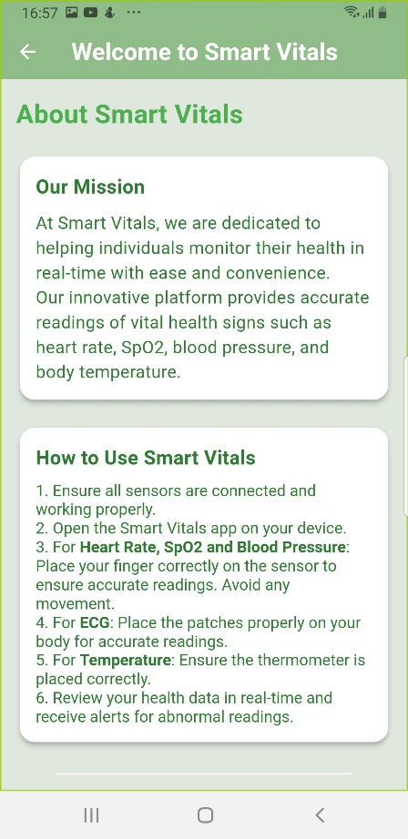

**Contact Us:**

The second icon is contact us, which contains contact information of smart vitals.

 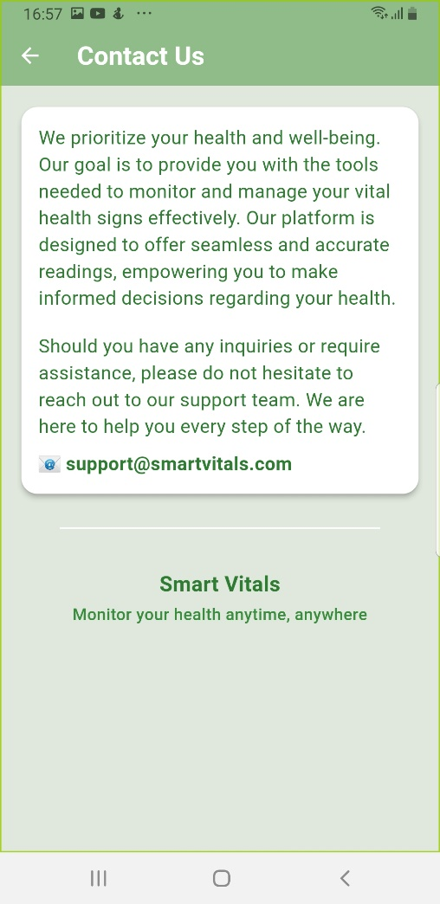

**Log out:**

The third icon is logout icon which redirect the users to the login page.

 